ICT2202 Digital Forensics Assignment 1

Team DigiFax

DigiTrace User Manual

**Team Members:**

Chin Clement (1802951)

Gerald Peh Wei Xiang (1802959)

Ho Xiu Qi (1802962)

**Keywords Used** **3**

**Setup and Launch the tool** **4**

**Start a New Case** **5**

**Open an Existing Case** **6**

**Filter Primary Addresses** **7**

**Add Primary Address** **8**

**Query Primary Address’s Transactions** **9**

**Customize Primary Address Profile Information** **10**

**Open Primary Address in Etherscan Website** **11**

**Hover Primary Address for Total Transaction Count** **12**

**Secondary Address Filter** **13**

**Change Secondary Address Display Order** **14**

**View Detailed Transactions of Secondary Address** **15**

**View Specific Transaction on Etherscan Website** **16**

**Add Relationship** **17**

**Drop Relationship** **18**

**Drop Primary Address** **19**

**Save Case Data** **20**

**Save Case Data as Separate Case File** **21**

**Open another Case** **22**

**Close Current Case Dashboard** **23**

**Show Keyboard Shortcuts** **24**

# Keywords Used

* **Primary Address**
  + Each address in the Nodes List

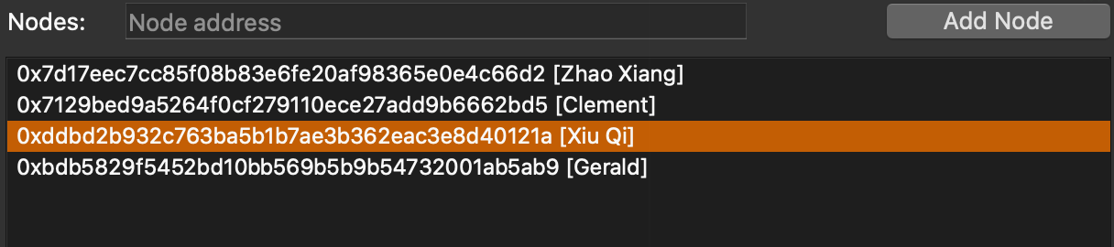

* **Secondary Address**
  + Each unique transaction address in the Transactions List

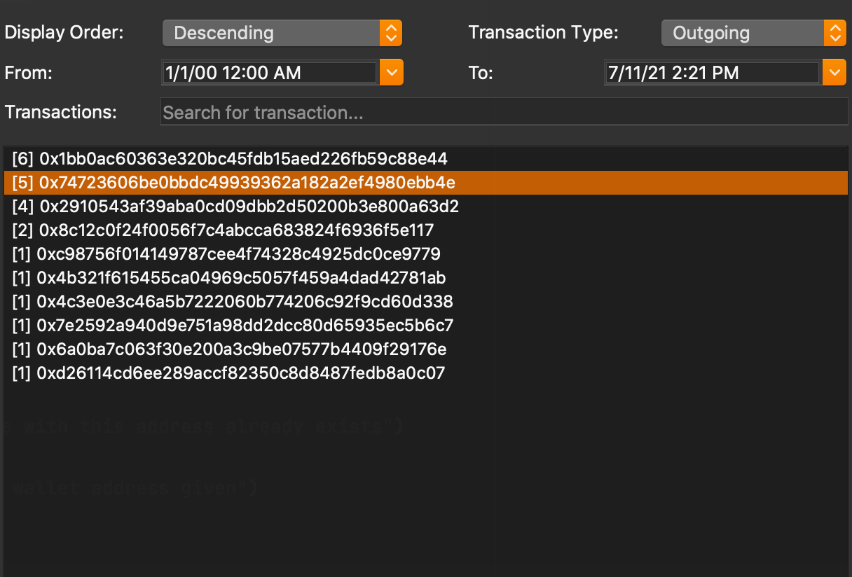

* **Case Data**
  + Includes Case Name, Case Description, Primary Addresses added by investigator, any queried Transaction Data and Stats

# Setup and Launch the tool

1. Clone the project folder into local file system
2. Navigate to project folder
3. Run
   1. pip3 install -r requirement.txt
   2. python3 __init__.py
4. Tool should open up the Home window

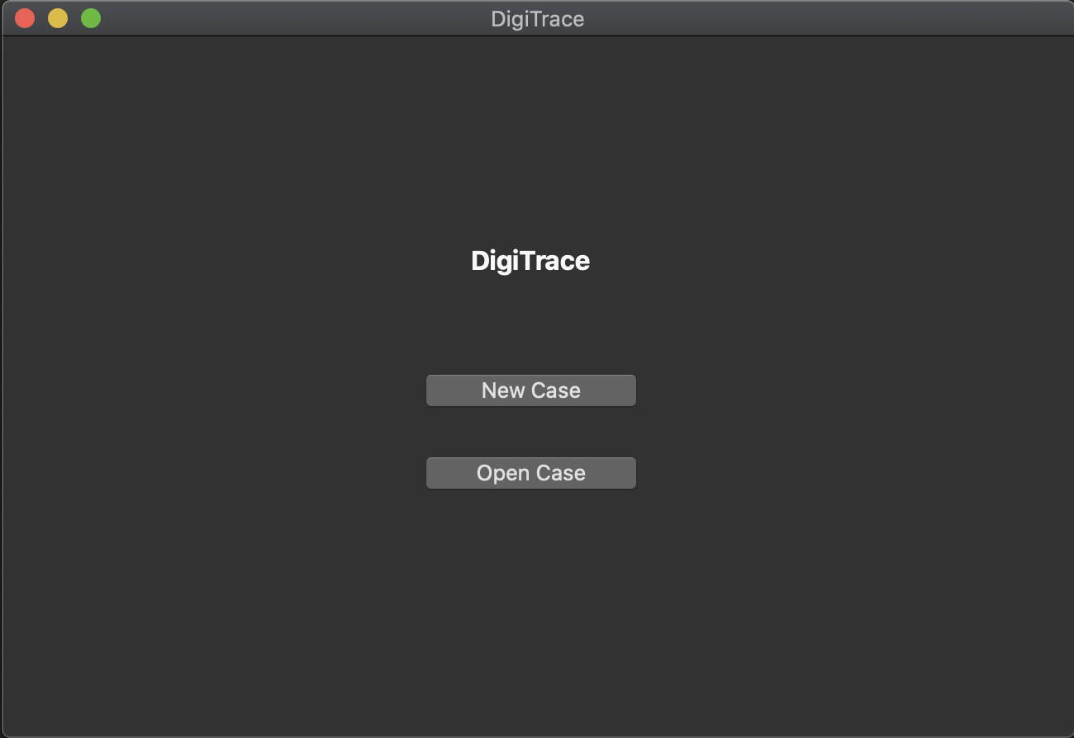

# Start a New Case

1. Press the “New Case” button on the Home window
2. The New Case window should popup

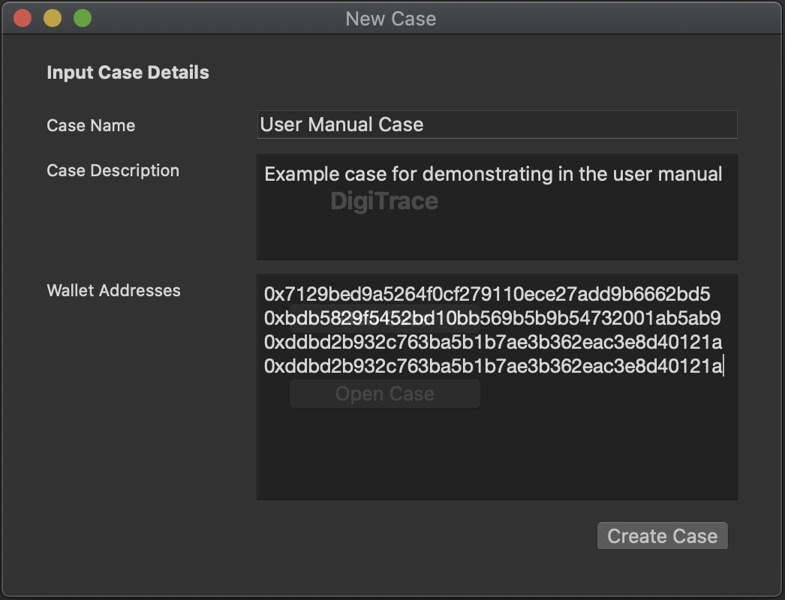

1. Input a case name (will be used as case file name “<name>.json”)
2. Input a case description
3. Input wallet address(es) to start the case with, where multiple addresses are separated by line breaks (you can do this later on if you wish to, there’s no difference)
4. Press the “Create Case” button to create the case
5. Tool should open a dashboard window with information typed earlier in steps (3) - (5)

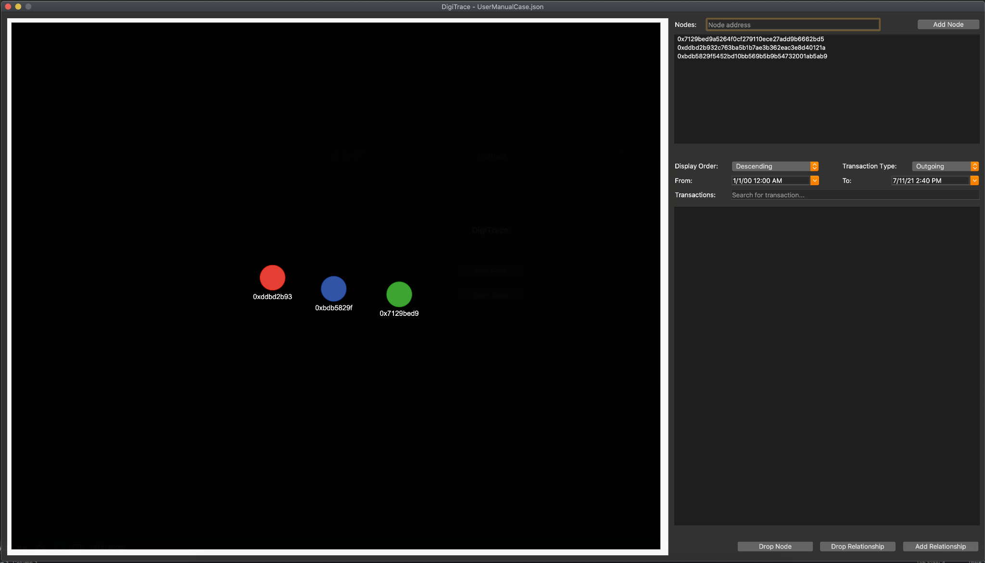

# Open an Existing Case

1. Press the “Open Case” button on the Home window
2. A file dialogue window will open
3. Select a target case file (“.json” format) and press “Open”

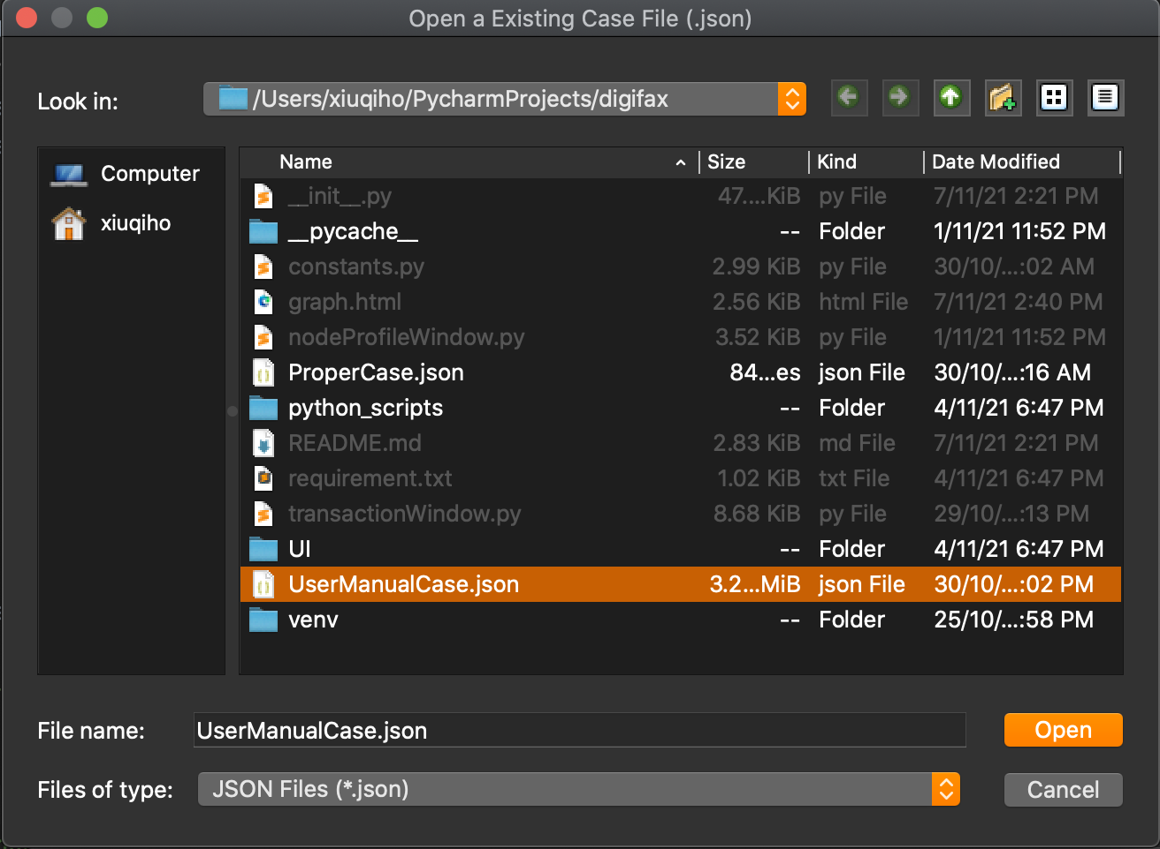

1. Tool should open a dashboard window with case information from the case file in (3)

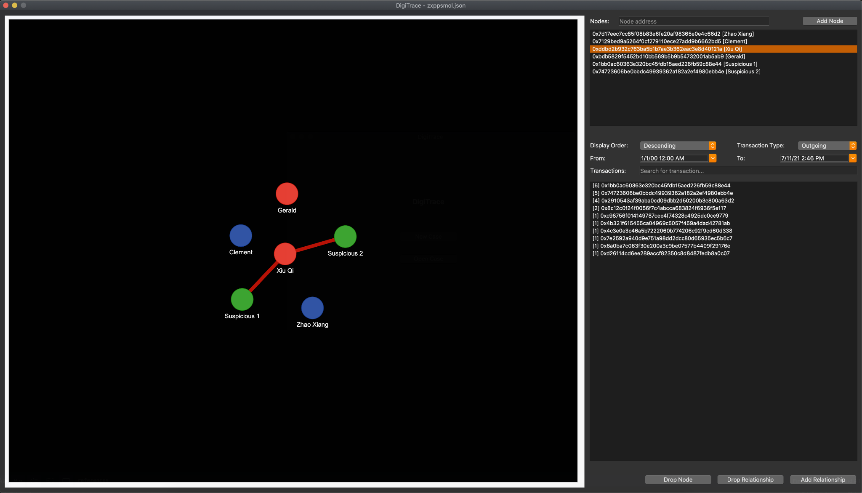

# Filter Primary Addresses

1. Input a wallet address to filter the nodes (primary addresses) list by
2. Each time the search box is modified, the corresponding address filter result is displayed

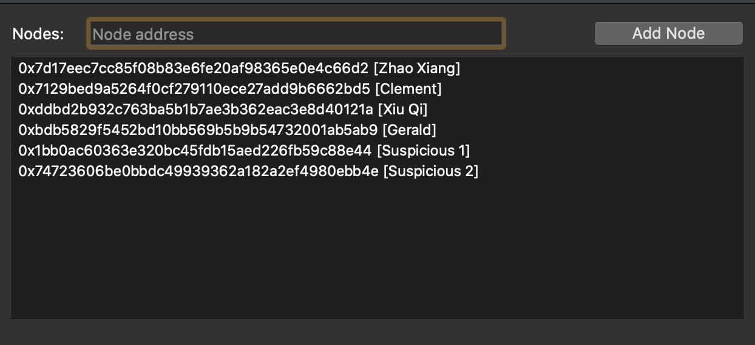

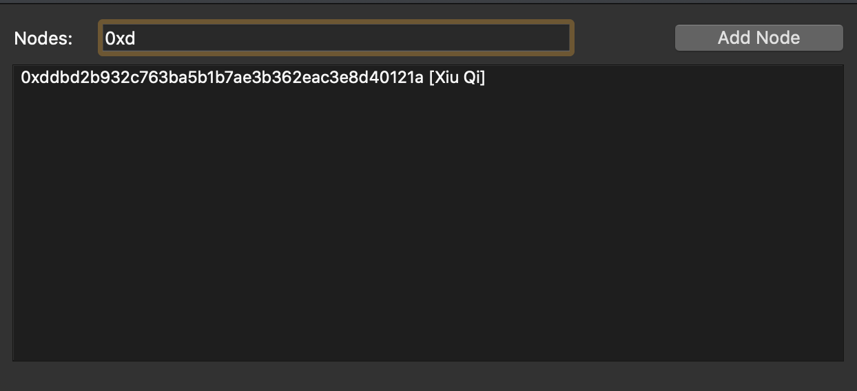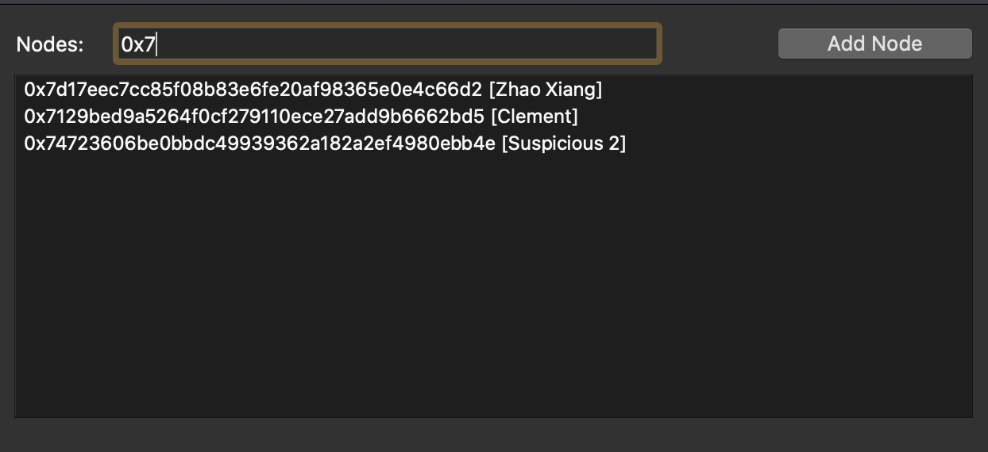

# Add Primary Address

1. Input a valid wallet address in the search box

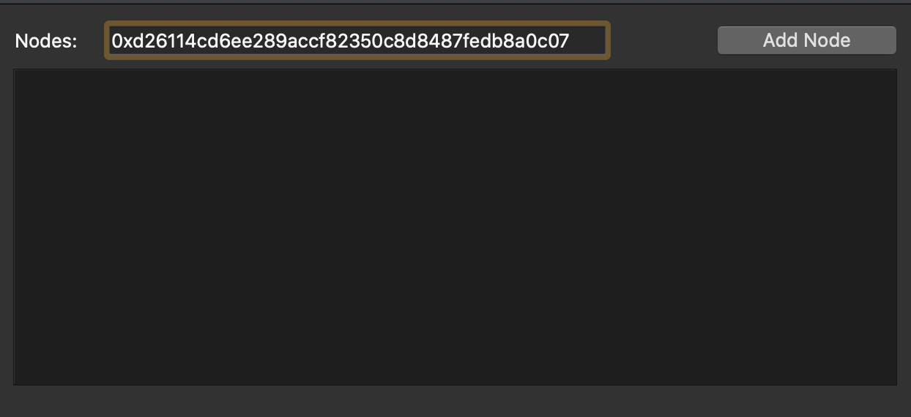

1. Press the “Add Node” button, address will be added to the nodes (primary address) list if it does not already exist

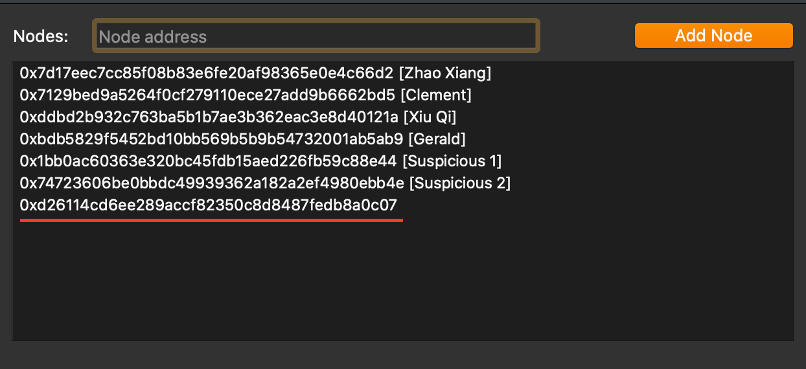

# Query Primary Address’s Transactions

1. Click on any node (primary address) in the Nodes List
2. If transaction data for this primary address does not exist yet, the tool will query for it using the “***DigiFax_EthScan_multiproc.py***” backend script

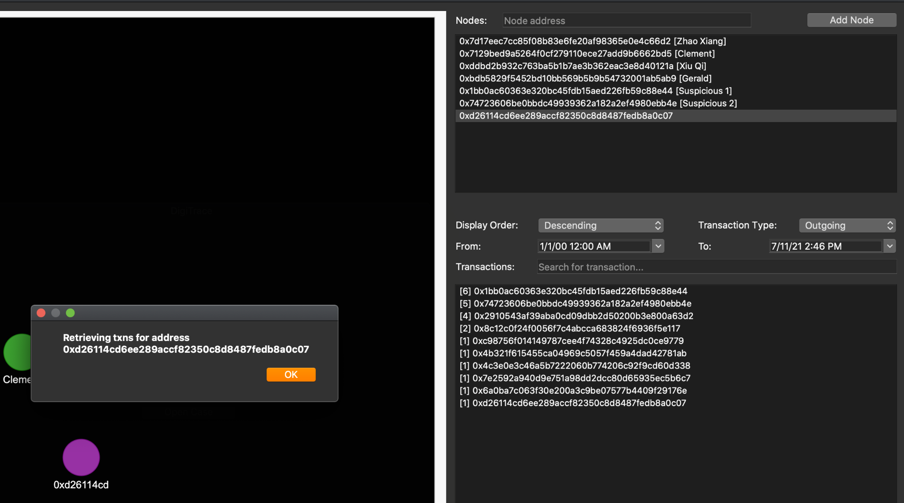

1. After awhile, click on the same node (primary address) to see its queried transaction data (secondary addresses)

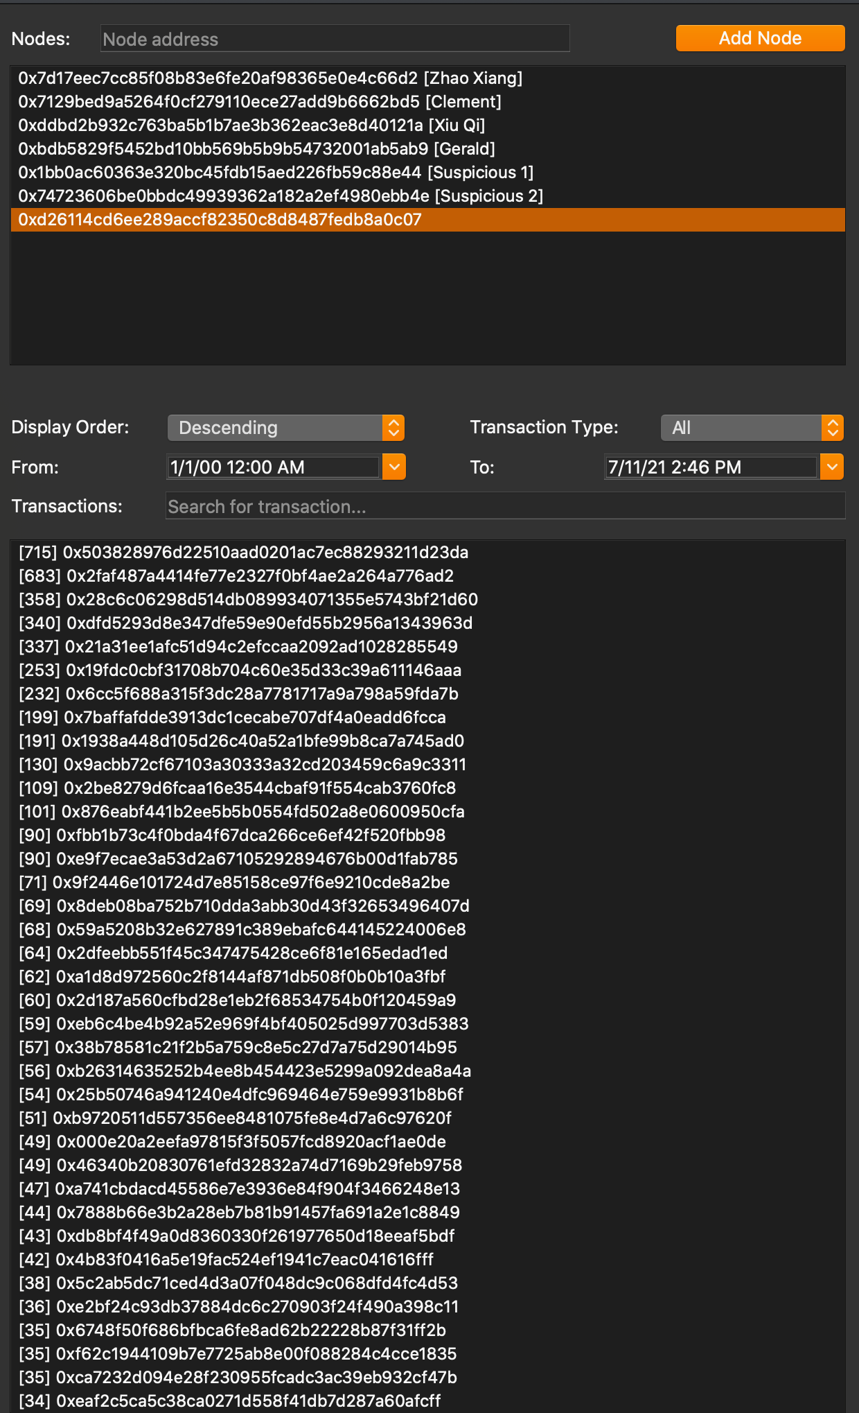

# Customize Primary Address Profile Information

1. Double click on a specific node (primary address) in the Nodes List
2. Tool should open the corresponding Node Profile window for that node (primary address)
3. Fill in desired description and alias (both are optional)

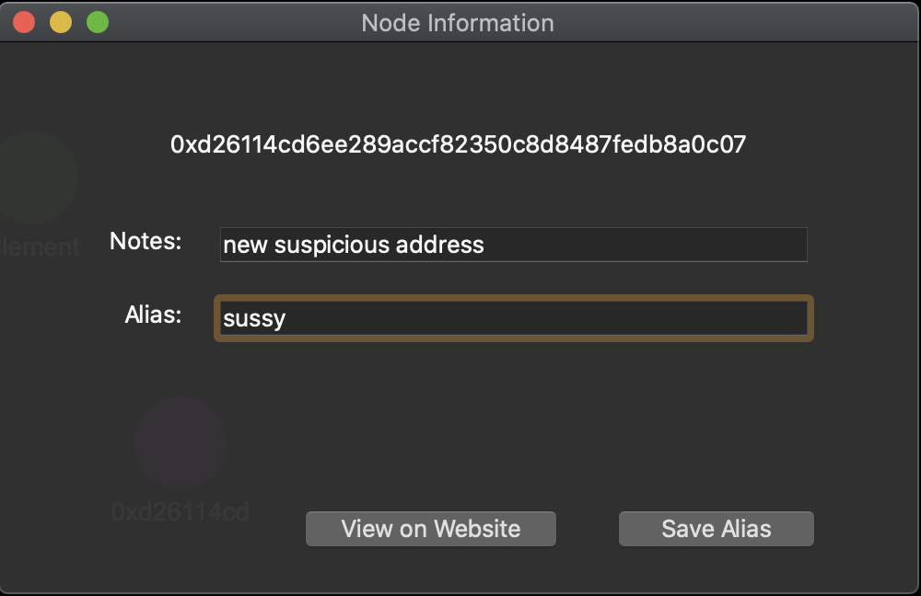

1. Press the “Save Alias” button
2. If an alias was entered, it should be reflected in the Nodes List and the node’s display label in the Nodes Graph

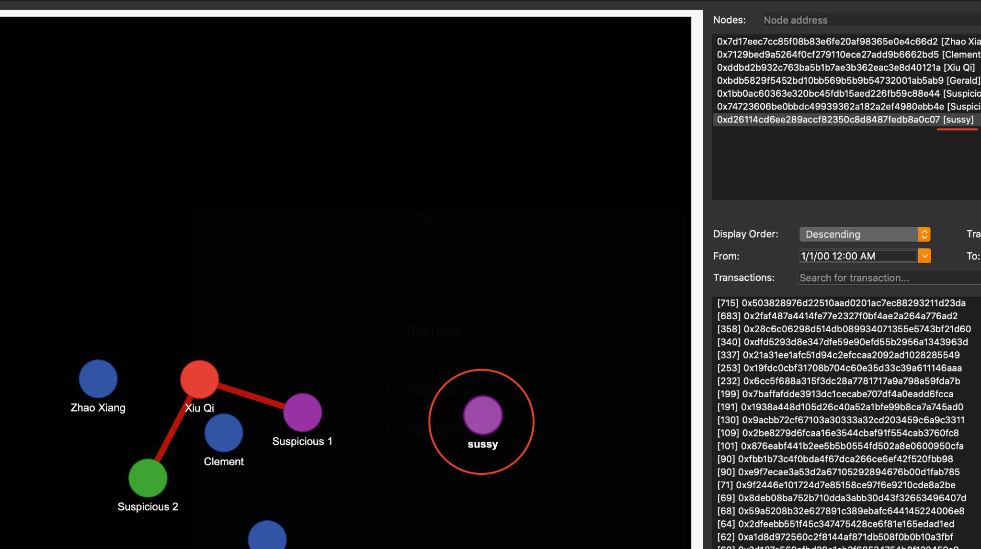

# Open Primary Address in Etherscan Website

1. Double click on a specific node (primary address) in the Nodes List
2. Tool should open the corresponding Node Profile window for that node (primary address)



1. Press the “View on Website” button
2. Tool should open a browser window that displays the wallet information on the actual Etherscan Website

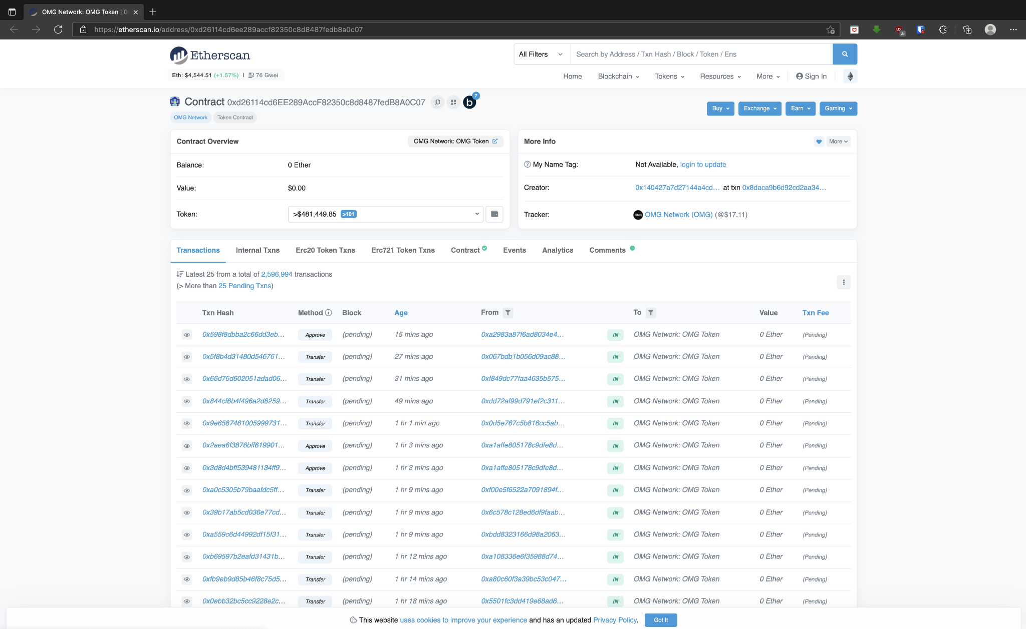

# Hover Primary Address for Total Transaction Count

1. Hover over a specific node (primary address) in the Nodes List
2. Tool show display a tooltip with information of total transactions that node (primary address) has

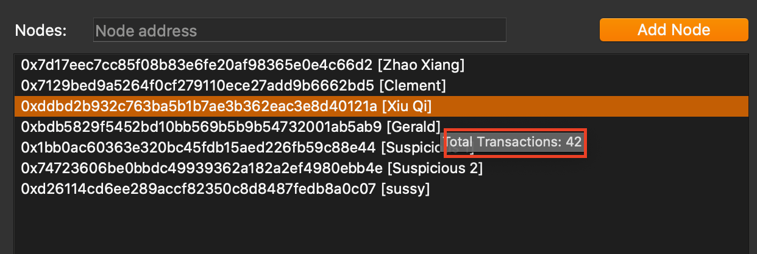

# Secondary Address Filter

1. Select desired transaction type to filter transactions (secondary addresses) by
   1. Outgoing (defaut)
   2. Incoming
   3. All
2. Select date-time range to filter transactions (secondary addresses) by
   1. Default is from **1st January 2020 00:00** to **Current Date-Time**
3. Input a wallet address to filter the transactions (secondary addresses) list by (OPTIONAL)

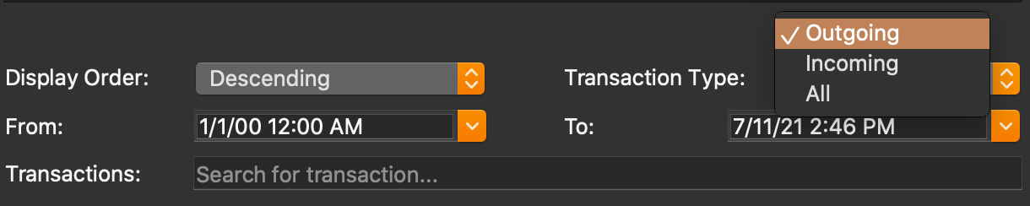

1. Transactions view will be filtered and displayed accordingly

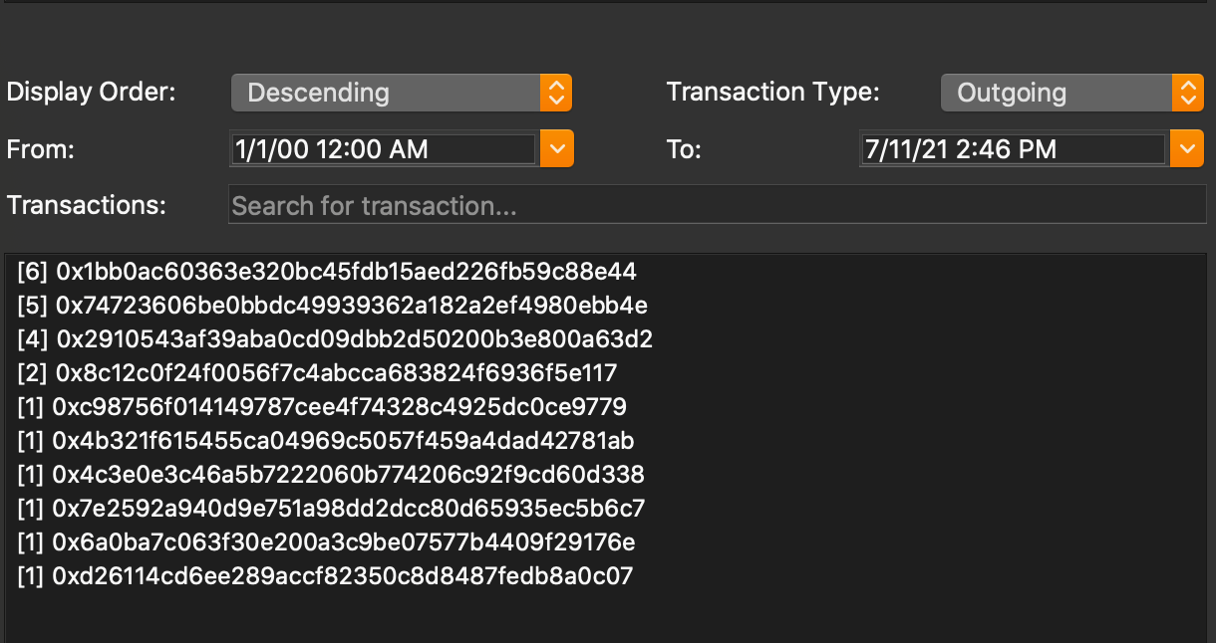

# Change Secondary Address Display Order

1. Select desired display order for transactions (secondary addresses) by
   1. Descending (default)
   2. Ascending

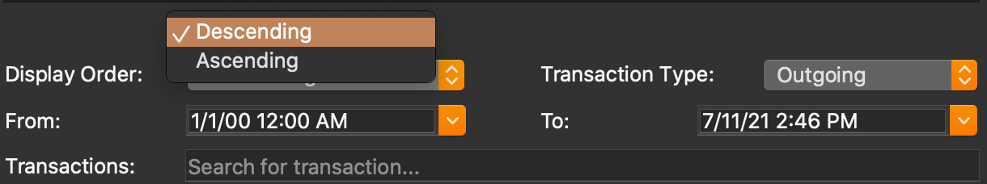

1. Tool should change the display order accordingly

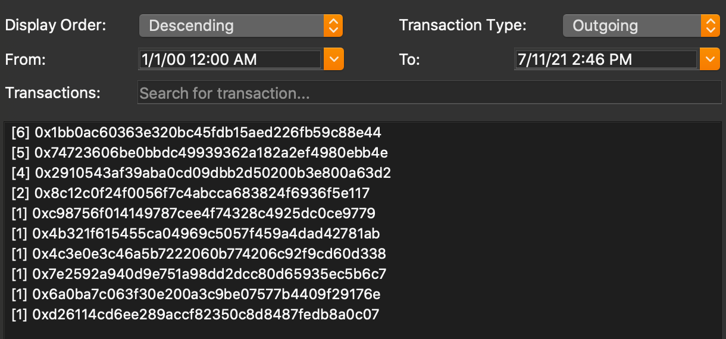

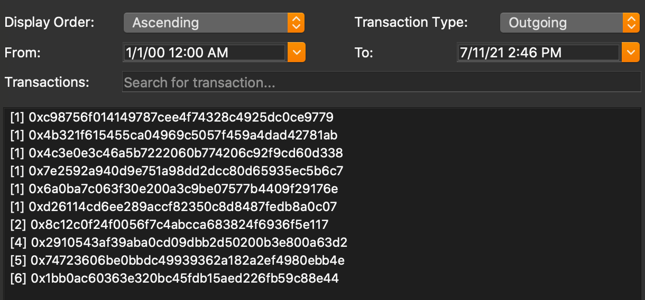

# View Detailed Transactions of Secondary Address

1. Double click on a unique transaction address (secondary address) in the Transactions List
2. Tool should open the Transaction window and lists the detailed transactions between the selected node (primary address) and the selected unique transaction address (secondary address)
   1. For each transaction, following information is available
      1. Date-Timestamp of transaction
      2. Transaction Direction (Outgoing / Incoming)
      3. From address and labels
      4. To address and labels
      5. Value
      6. Hash
      7. Block Number

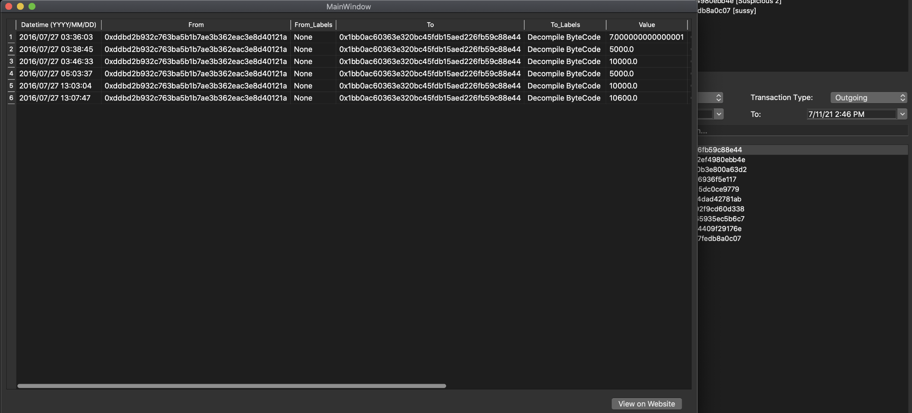

# View Specific Transaction on Etherscan Website

1. Double click on a unique transaction address (secondary address) in the Transactions List
2. Tool should open the Transaction window and lists the detailed transactions between the selected primary address and secondary address



1. Select any column of interested transaction and click on the “View on Website” button

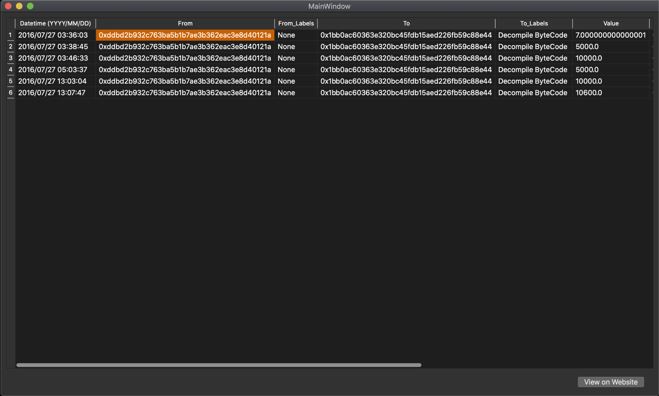

1. Tool should open a browser window that displays the transaction information on the actual Etherscan Website

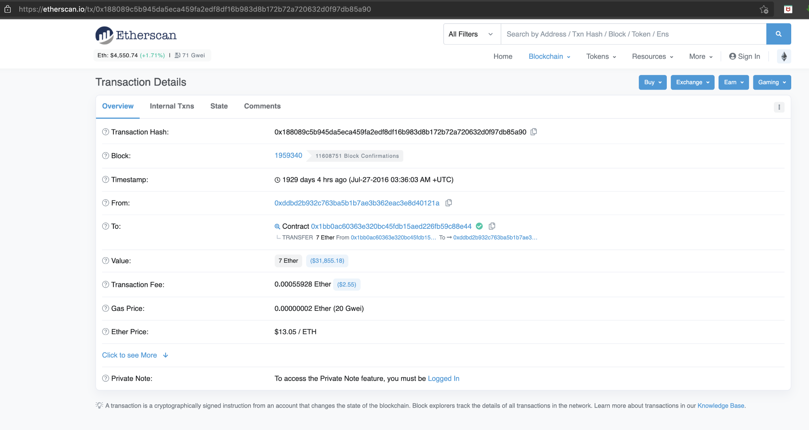

# Add Relationship

1. Select a node (primary address) in the Nodes List

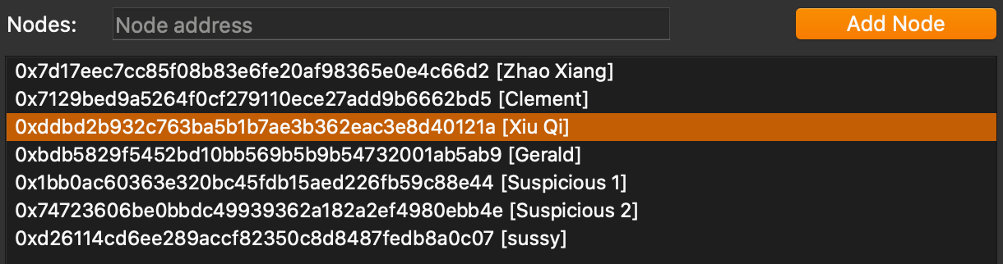

1. Select a unique transaction address (secondary address) in the Transaction List

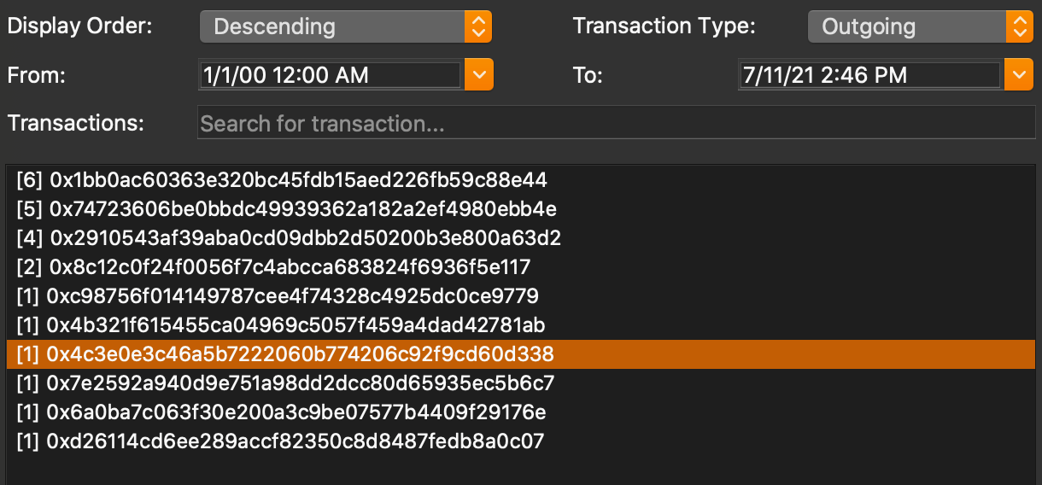

1. Press the “Add Relationship” button
2. If new relationship includes a node that does not already exist in the Node List (and the Nodes Graph), it is added and the list & graph will be updated

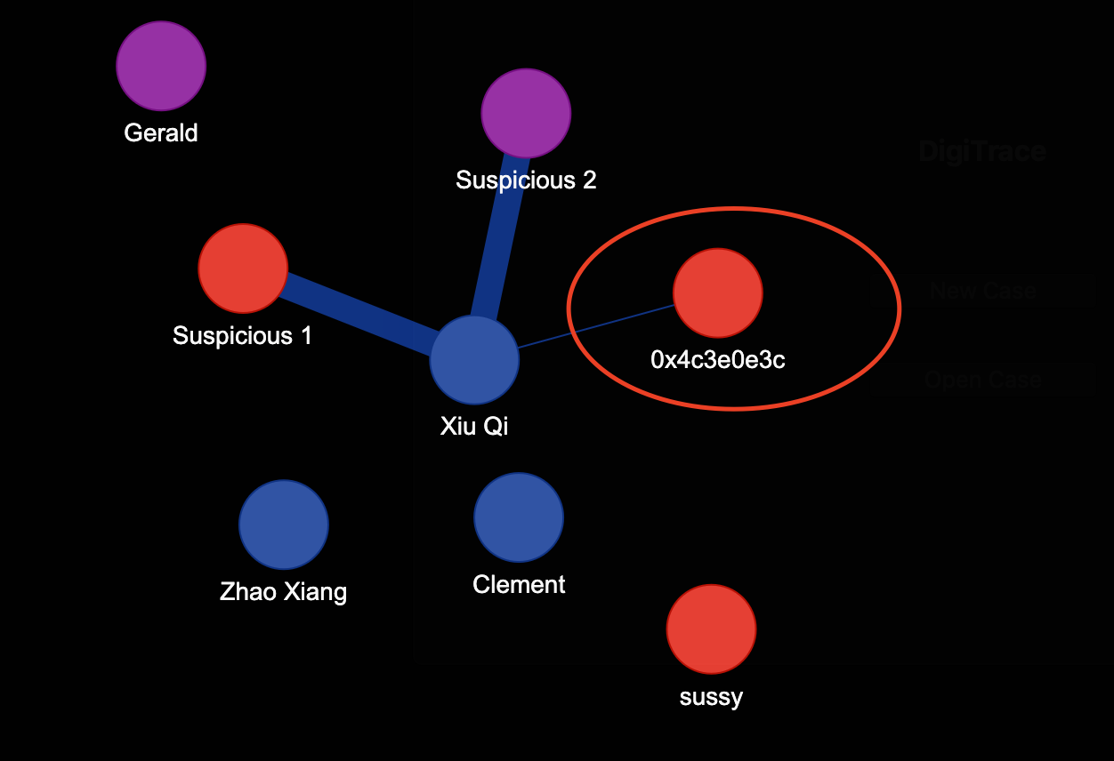

1. If relationship to add does not already exist, the relationship is updated in the Nodes Graph (weight / thickness of relationship determined by number of transactions the primary and secondary address have in common

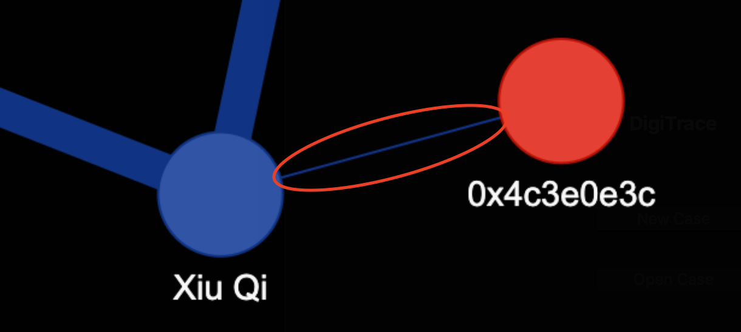

# Drop Relationship

1. Select a node (primary address) in the Nodes List



1. Select a unique transaction address (secondary address) in the Transaction List



1. Press the “Drop Relationship” button
2. If relationship to drop exists, the relationship (line) is removed from the Nodes Graph
3. After removing the relationship, if node does not have any more relationships, it will be removed from the Nodes List and Nodes Graph
   1. Before



* 1. After

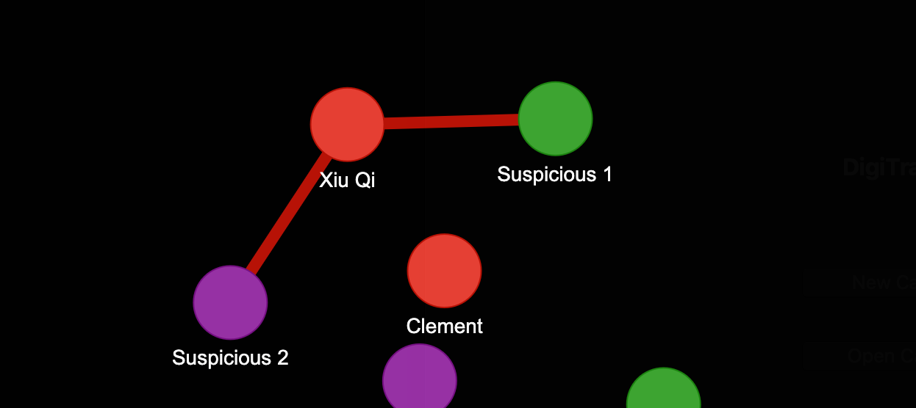

# Drop Primary Address

1. Select a node (primary address) in the Nodes List

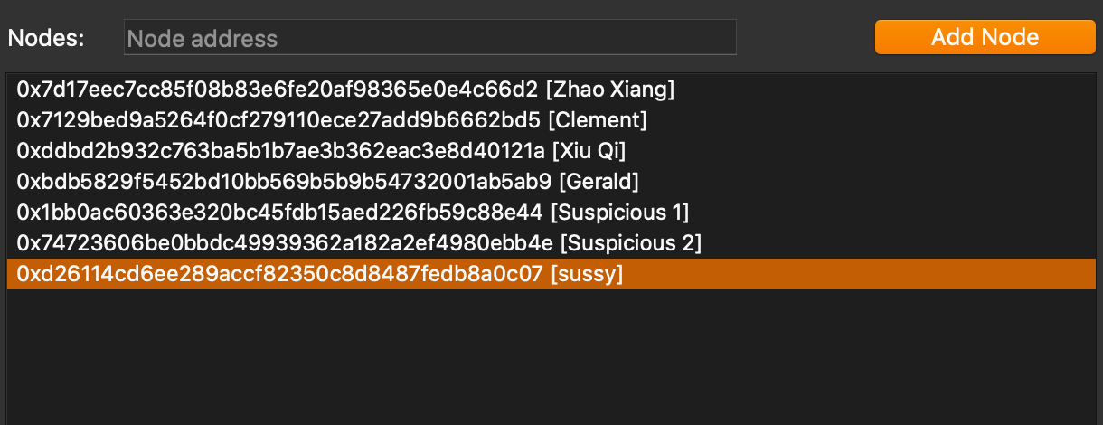

1. Press the “Drop Node” button
   1. Before

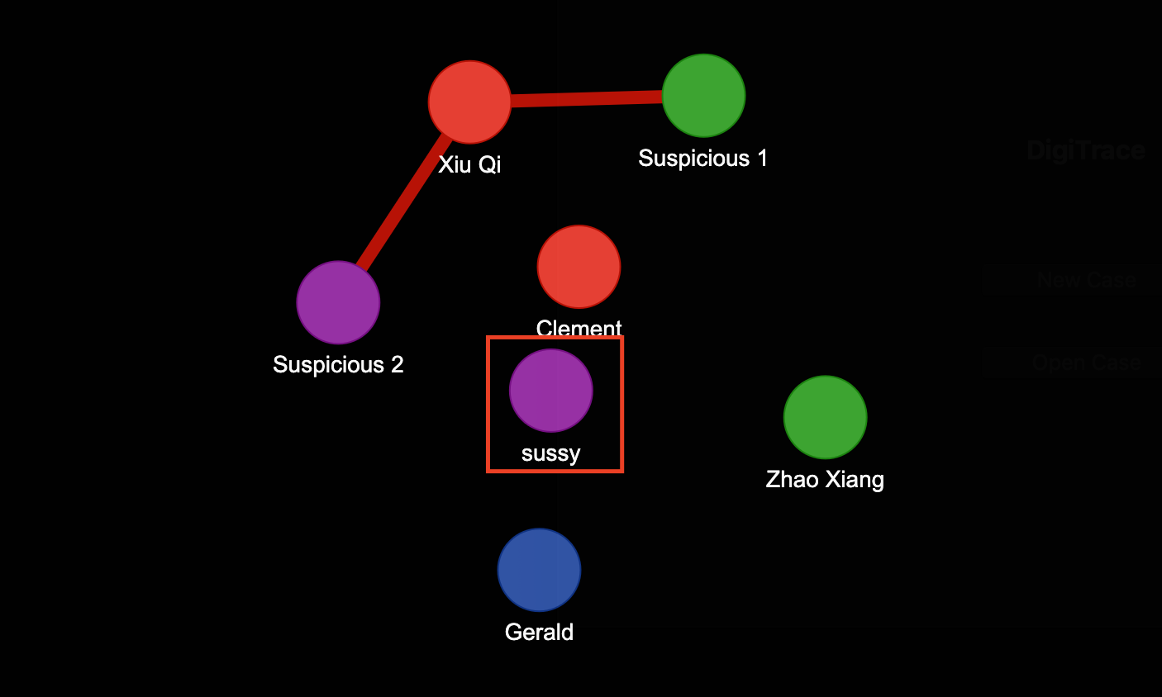

* 1. After

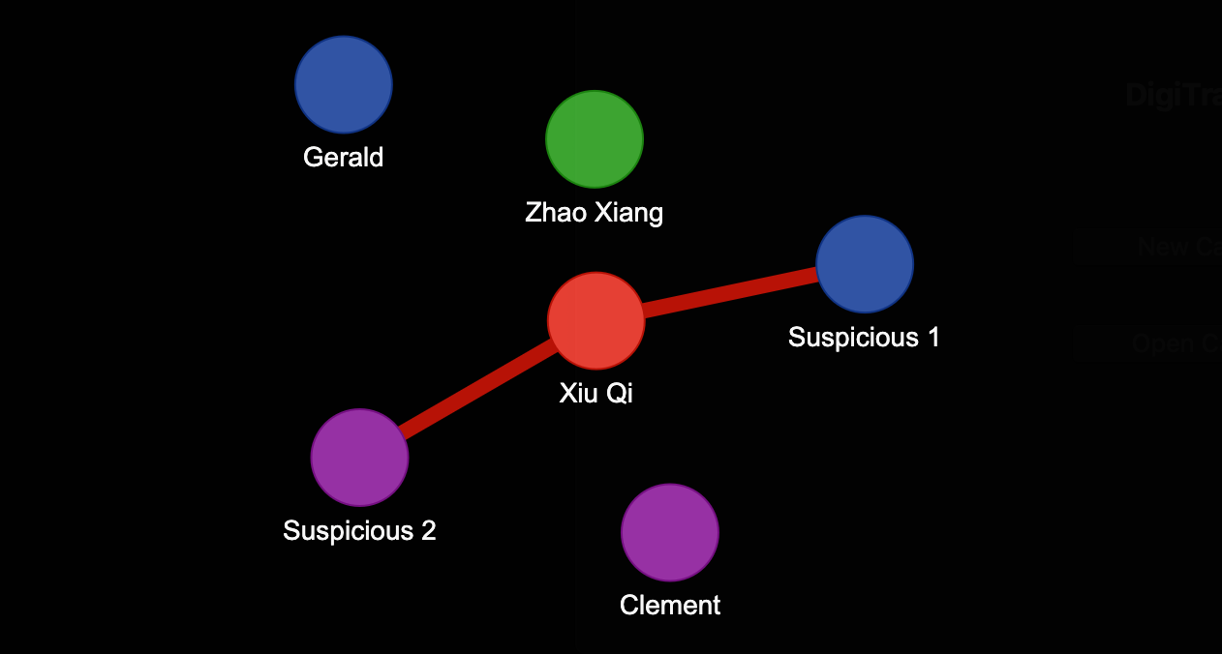

# Save Case Data

1. Click on “File” on the menu bar
2. Select “Save” to save all current Case Data into the current case’s file

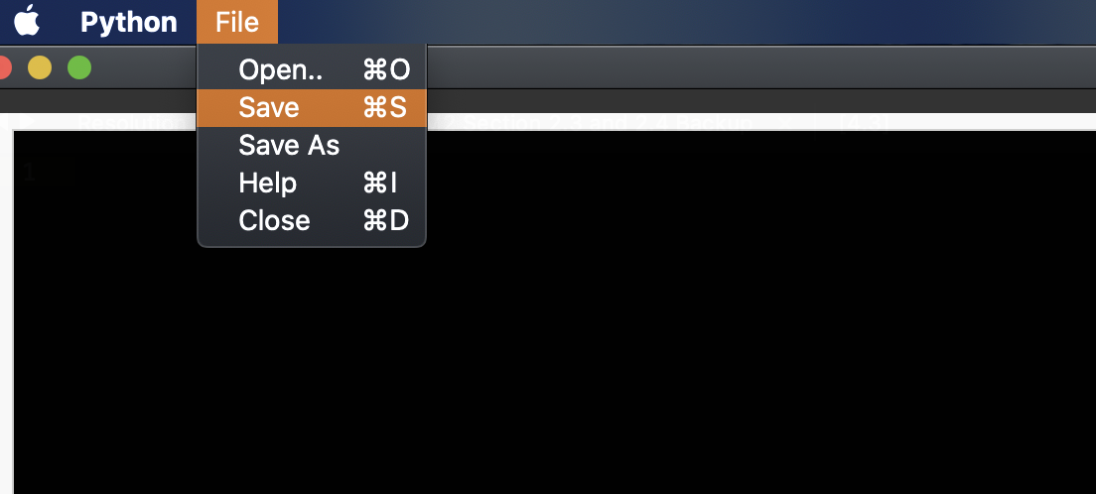

1. Alternatively, press “CTRL+S” on Windows, or “CMD+S” on Mac

# Save Case Data as Separate Case File

1. Click on “File” on the menu bar
2. Select “Save As” to save all current Case Data as another case file

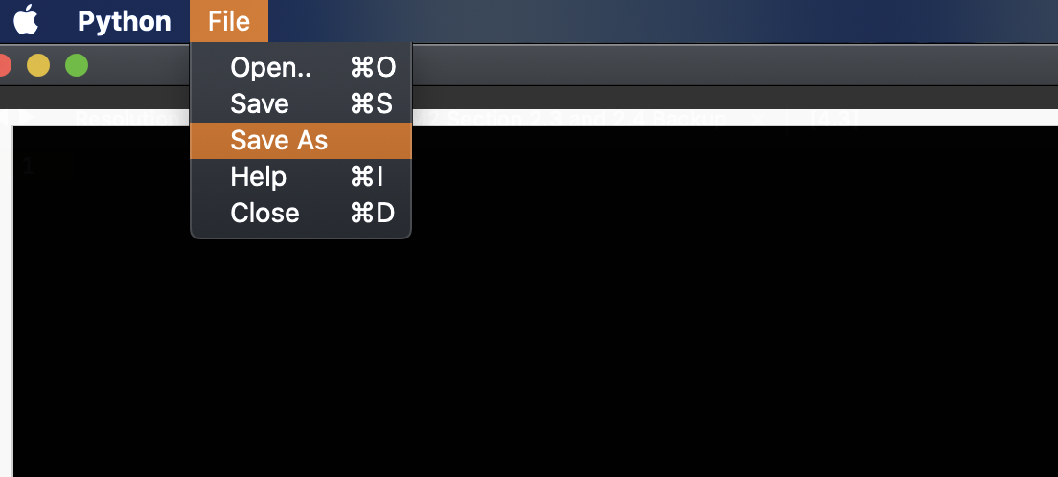

1. Select folder and input desired case file name, and press “Save”

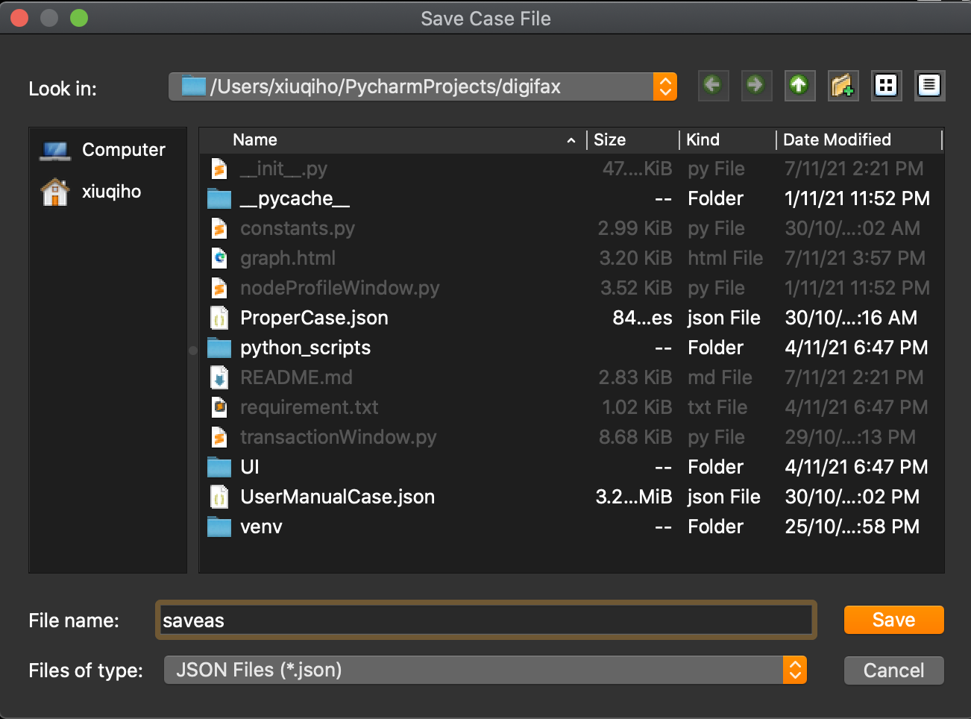

# Open another Case

1. Click on “File” on the menu bar
2. Select “Open” to open another existing case
   1. Alternatively, press “CTRL+O” on Windows, or “CMD+O” on Mac

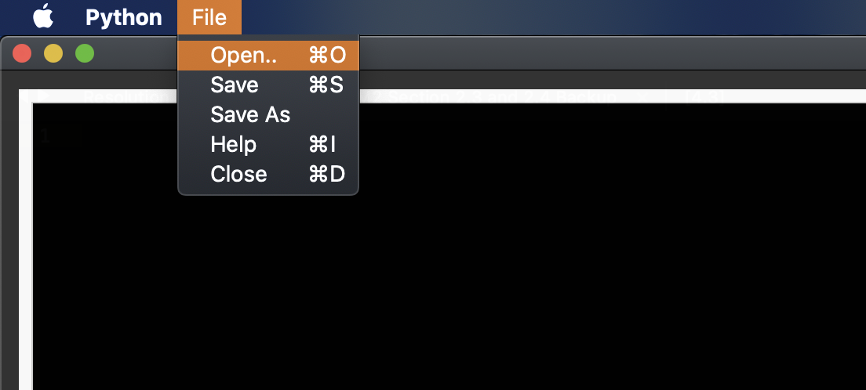

1. Select an existing case file (“.json” format) and press “Open”

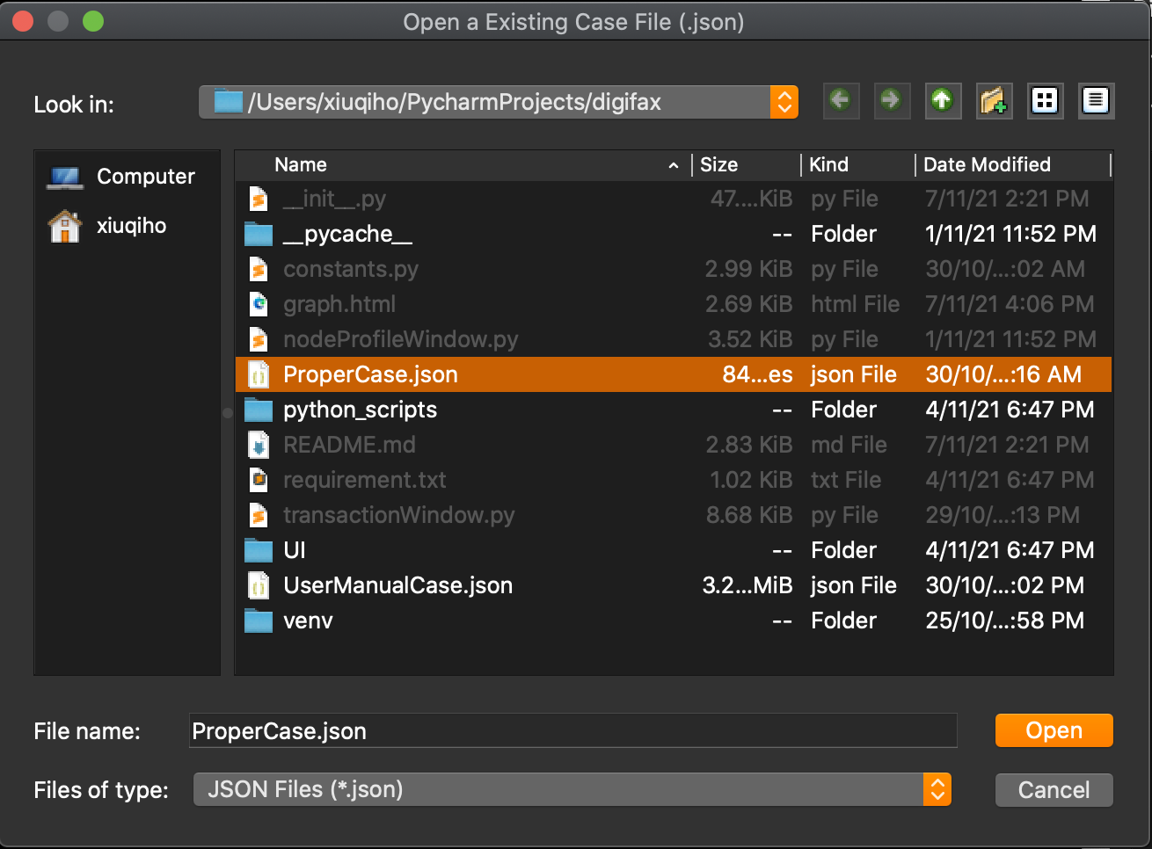

1. Tool should open the selected case file in (3) on the current dashboard window

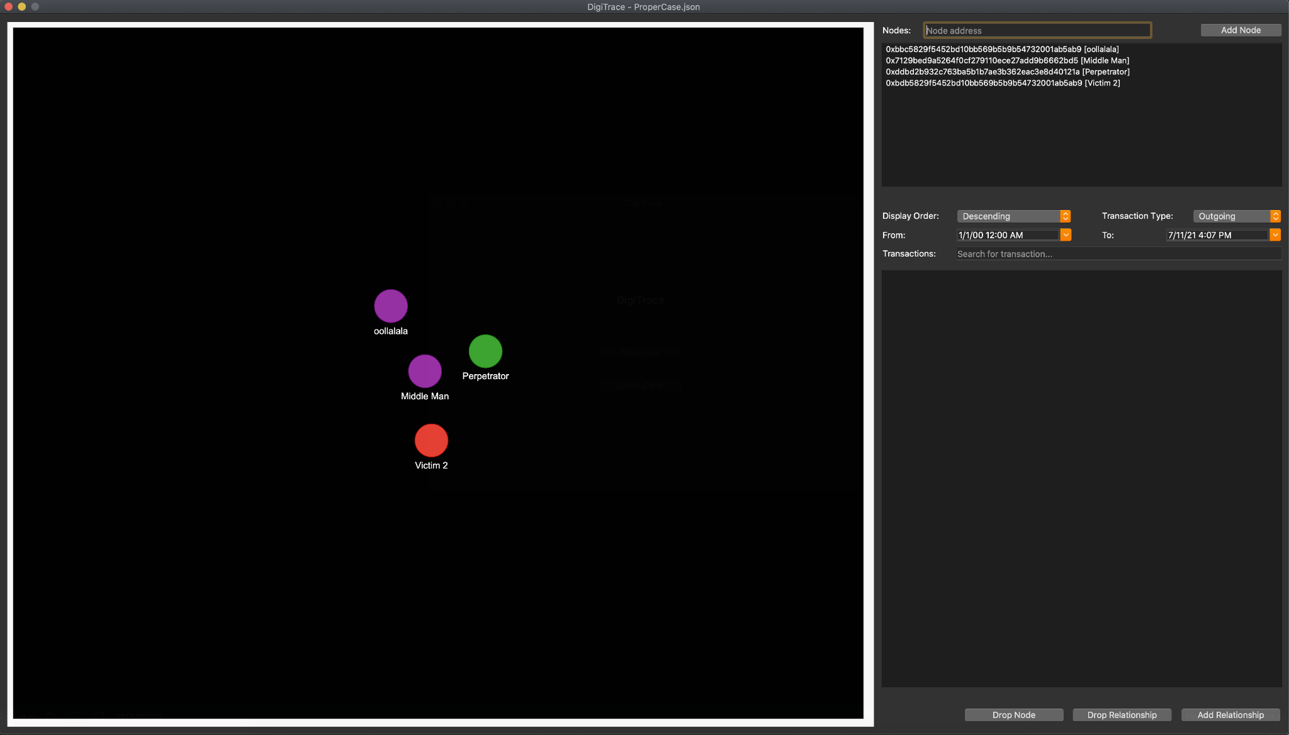

# Close Current Case Dashboard

1. Click on “File” on the menu bar
2. Select “Close” to close the current case’s dashboard window

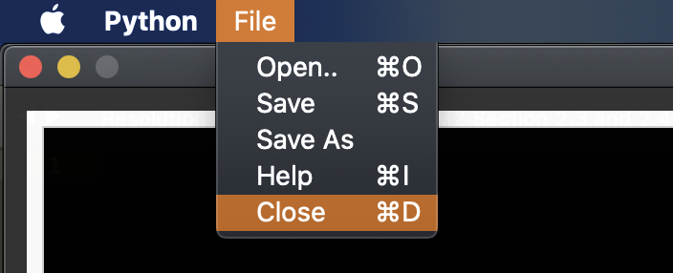

1. Tool should bring you back to the Home window

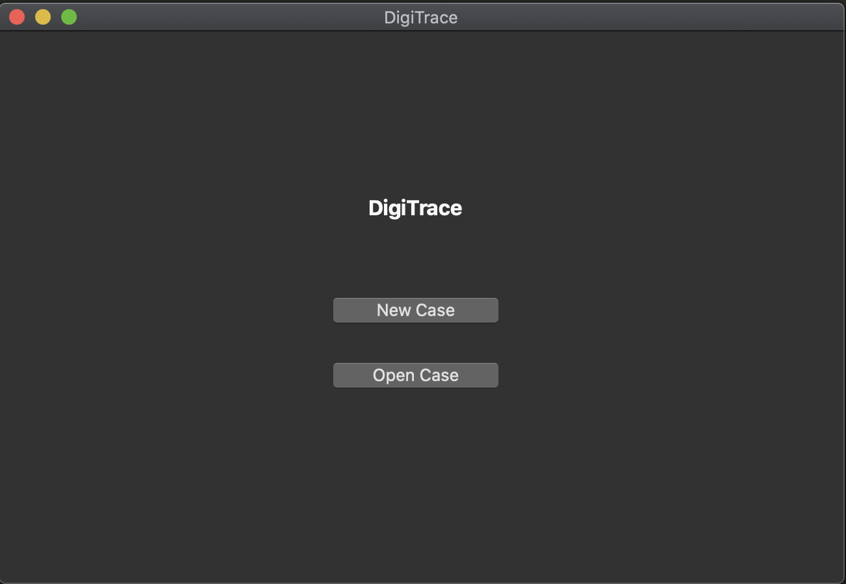

# Show Keyboard Shortcuts

1. Click on “File” on the menu bar
2. Select “Help” to open help information window on the available shortcuts in the dashboard window
   1. Alternatively, press “CTRL+I” on Windows, or “CMD+I” on Mac

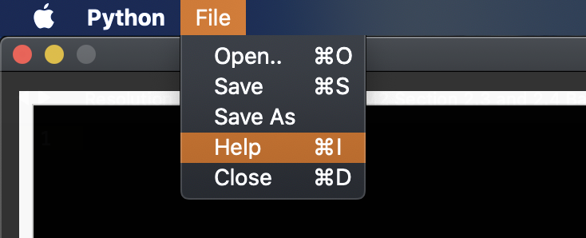

1. Tool opens the Help message box



 